**Project Design Phase**

**Problem – Solution Fit Template**

|  |  |
| --- | --- |
| Date | 18 February 2026 |
| Team ID | LTVIP2026TMIDS78786 |
| Project Name | Electric Motor Temperature Prediction System |
| Maximum Marks | 2 Marks |

**Problem – Solution Fit Template:**

The Problem–Solution Fit ensures that the proposed system solves a real industrial problem by understanding user needs, operational challenges, and behavioral patterns. The Electric Motor Temperature Prediction System focuses on preventing motor failures through predictive analytics and intelligent monitoring.

**Purpose:**

❑ Reduce unexpected motor failures in industries  
❑ Enable predictive maintenance instead of reactive maintenance  
❑ Improve operational efficiency and equipment lifespan  
❑ Provide early temperature prediction using machine learning  
❑ Support data-driven decision-making for maintenance teams

**Template:**

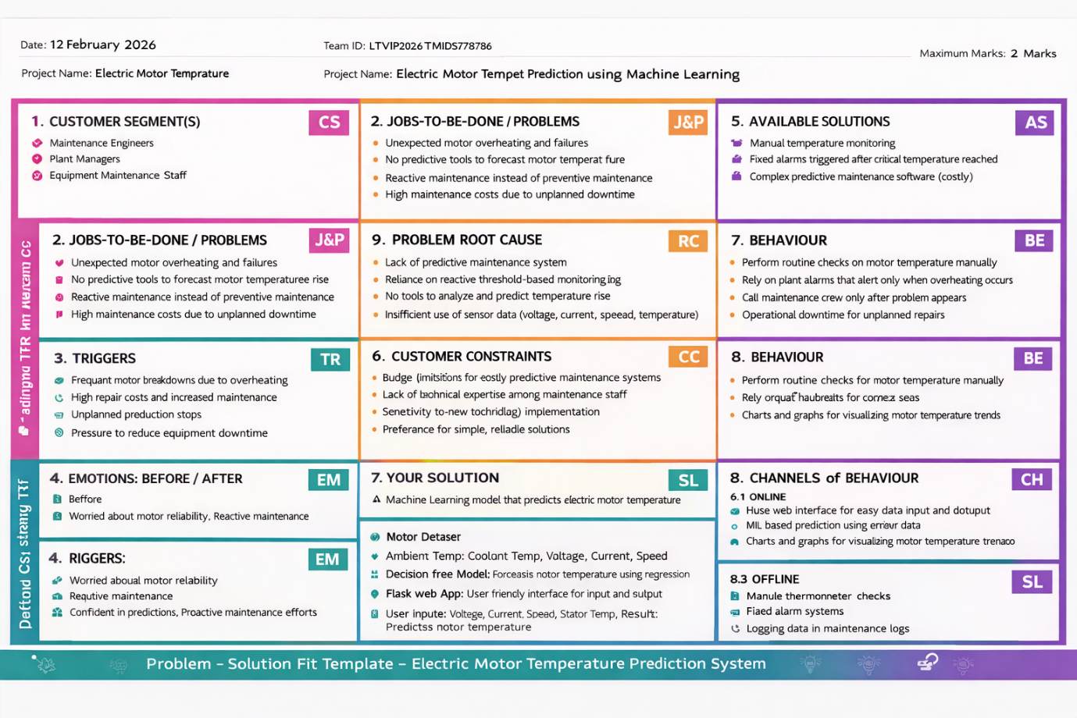

**Customer Discovery Sheet – Electric Motor Temperature Prediction System**

**1. CUSTOMER SEGMENT(S)**

Who is your customer?

• Industrial Plant Operators  
• Maintenance Engineers  
• Manufacturing Unit Managers  
• Electrical Engineers  
• Equipment Monitoring Teams

**2. JOBS-TO-BE-DONE / PROBLEMS**

Which problems does your system address?

• Sudden overheating of electric motors  
• Unexpected equipment breakdowns  
• Lack of early warning systems  
• Manual monitoring of motor temperature  
• High maintenance and repair costs  
• Inefficient preventive maintenance planning

**3. TRIGGERS**

What motivates them to act?

• Frequent motor failures  
• Production downtime losses  
• Increased repair expenses  
• Need for predictive maintenance solutions  
• Requirement for efficient energy utilization

**4. EMOTIONS: BEFORE / AFTER**

**Before:**

• Worried about sudden machine failures  
• Reactive maintenance approach  
• Lack of confidence in manual monitoring  
• Stress due to unexpected downtime

**After:**

• Confident with early temperature prediction  
• Reduced maintenance stress  
• Improved operational reliability  
• Better planning of maintenance schedules

**5. AVAILABLE SOLUTIONS**

What exists today?

• Threshold-based alarm systems  
• Manual temperature monitoring  
• Periodic maintenance inspections  
• Basic sensor monitoring without prediction capability

**6. CUSTOMER CONSTRAINTS**

What stops them from acting?

• High cost of advanced monitoring systems  
• Limited AI adoption in traditional industries  
• Lack of technical expertise  
• Integration challenges with existing systems  
• Resistance to technology transition

**7. BEHAVIOUR**

What do users do today to solve these problems?

• Monitor temperature manually at intervals  
• Use fixed temperature alarms  
• Perform maintenance only after failure occurs  
• Depend on technician experience for decisions

**8. CHANNELS OF BEHAVIOUR**

**8.1 ONLINE:**

• Web-based prediction system (Flask application)  
• Machine learning prediction dashboard  
• Sensor data analysis tools

**8.2 OFFLINE:**

• Manual inspection of motors  
• Scheduled maintenance logs  
• Physical monitoring instruments

**9. PROBLEM ROOT CAUSE**

Why does the problem exist?

• Lack of predictive analytics in monitoring systems  
• Dependence on threshold-based alerts  
• Insufficient analysis of historical sensor data  
• Absence of intelligent maintenance tools.

**10. YOUR SOLUTION**

What do you offer?

A Machine Learning–based Electric Motor Temperature Prediction System featuring:

• Data preprocessing and feature scaling using MinMaxScaler  
• Regression models (Linear Regression, Decision Tree, Random Forest, SVR)  
• Decision Tree model for accurate temperature prediction  
• Flask-based web application for user interaction  
• Real-time temperature prediction using input parameters  
• Visualization and performance evaluation using RMSE and R² score  
• Future-ready architecture for IoT sensor integration and automated alert.